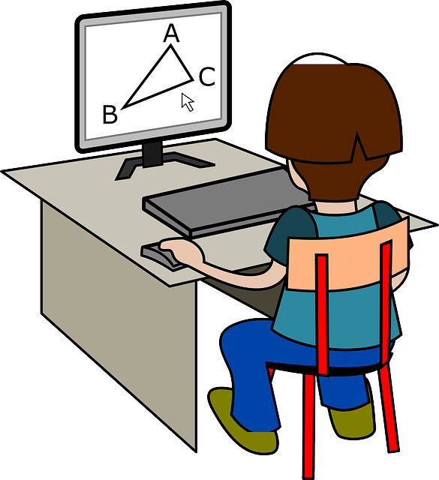
ACCEPTABLE USE GUIDELINES for
HIGH SCHOOL STUDENTS & STAFF

Digital Citizenship
It is a goal of YK1 to develop good Digital Citizens who can make decisions and operate technology appropriately and responsibly. While using district technology resources, students and staff shall demonstrate appropriate and responsible use in the elements of Digital Citizenship.
A Good Digital Citizen:
- Uses technology resources for learning
- Uses good ‘netiquette’
- Respects privacy; their own and others
- Respects copyright and other laws
- Protects themselves from technological dangers such as identity theft and other predators
- Is a life-long learner
- Keeps passwords private
A Good Digital Citizen DOES NOT:
- Use profanity in electronic communications
- Share obscene/pornographic materials electronically
- Use technology or network resources in an illegal or unethical manner
- Hack into others information
- Download illegal digital media
- Plagiarize
- Create or distribute worms or viruses
- Hamper the operations of the YK1 network
- Cyberbully
Reference: http://www.digitalcitizenship.net/Nine_Elements.html

Expectations and Responsibilities - Staff
- YK1 staff are expected to be familiar with the school policies concerning student technology use.
- All staff who utilize school technology for instructional purposes with students have a professional responsibility to help students develop information literacy skills.
- School personnel have a responsibility to protect and respect the confidentiality of all electronically stored student, parent, and staff information according to federal and territorial laws.
Expectations and Responsibilities - Students
- Students are encouraged to use technology equipment under adult supervision to further learning opportunities.
- Students shall not provide their name, address or photograph to people or companies on the Internet and Web without permission of parent(s) and a teacher.
Expectations and Responsibilities - Students & Staff
- Do not install any software on District computers without permission from the District technology support staff.
- Keep your passwords secret, change passwords if asked, and respect the privacy of others’ passwords.
- E-mail message are not necessarily secure or private. Users should be cognizant of this fact and make every effort to ensure that any confidential information that is sent by e-mail is sent to only those who should have access to this information.
- Licenses are purchased for the rights to use most software. Don’t make a copy of district software for use on other computers.
- Treat district technology equipment with care and attention.
- Participate in training to learn how to properly use technology equipment (when offered).
- I will abide by the rules of the computer and network use agreement at school even if I bring my own device to school.

Please sign and return this page to your child’s school. Thank you.

COMPUTER USE AGREEMENT
In return for the privilege of using the resources of the YK1 Computing Environment, I agree to abide by the Rules and Regulations for its’ use. I understand that failure to follow these rules can result in having my privileges restricted or taken away.

Staff/Student Name (Please Print)

Signature of Staff/Student

Date:

School:

I have discussed these rules with my child and my child agrees to follow them.

Signature of Parent(s)/Guardian(s) if a student

I do not agree with the terms of the YK1 Computer Use Agreement and understand that my child will not participate in activities that involve the use of computers or the Internet in the school.

Signature of Parent(s)/Guardian(s)

Please sign where appropriate and RETURN TO THE SCHOOL. Until the signed approval is returned to the school the student will not be able to participate in activities that involve the use of computers (school or personal) in the school.

TECHNOLOGY - Enforcement Outside of School
YK1 expects that the values we try to instill in every child are carried with them when they are not on school grounds. That said, violation of computer use outside of school is impossible for us to monitor. If, however, the school becomes aware of computer misuse in the form of harassment, bullying, or abuse of anyone through the use of email, text messaging, instant messaging, or while participating in an online community, the district reserves the right to take disciplinary action as outlined under the YK1 Computer Use Agreement. Students who knowingly participate in such activities are at risk of having their computer use privileges suspended, depending on the violation.

If you have any questions or concerns with regards to technology, please contact the principal of your child’s school.

